**Software Testing Assignment Module–1**

1. **What is SDLC**
2. **SDLC** (Software Development Life Cycle) is a structure imposed on the development of a software product that defines the process for planning, implementation, testing, documentation, deployment, and ongoing maintenance and support.
3. **What is software testing?**
4. Software Testing is a process used to identify the correctness, completeness, and quality of developed computer software.
5. **Write SDLC phases with basic introduction**
6. **Phases:-**
7. **Requirements Collection/Gathering** -

Lack of clarity

Requirements confusion

Requirements Amalgamation

1. **Analysis** -

This phase identifies the customer's problem and results in a clear requirement document that defines what needs to be built.

1. **Design** –

This phase creates the design and implementation plan based on the requirement document, including priority, performance, and test analysis.

1. **Implementation** –

The implementation phase involves coding the product based on design and requirements, focusing on quality, performance, and error removal.

1. **Testing** –

Quality is key to customer satisfaction and loyalty. Testing includes unit, regression, stress, and internal testing.

1. **Maintenance** –

Corrective maintenance

Adaptive maintenance

Perfective Maintenance

1. **Explain Phases of the waterfall model**
2. 1. Requirements Collection/Gathering

2. Analysis

3. Design

4. Implementation

5. Testing

6. Maintenance

The classical software lifecycle models the software development as a step – by – step waterfall between the various development phases

**Pros (Why Waterfall Model):**

Simple and easy to use.

Easy to manage with clear steps.

Best for small defined projects.

**Cons (Why Not Waterfall Model):**

Not good for complex or long projects.

Hard to handle changing requirements.

Difficult to track progress during phases.

**5. Write phases of spiral model**

a. 1. Planning

2. Risk Analysis

3. Engineering

4. Customer Evaluation

**6. What is agile methodology?**

a. Agile is a method of software development that delivers work in small parts sprints, allowing quick changes and continuous improvement.

**7. Write agile manifesto principles**

a. Customer satisfaction through early and continuous software delivery.  
 Welcome changing requirements anytime during development.  
 Face-to-face communication is most effective.  
 Close collaboration between business and developers.

**8. Explain working methodology of agile model and also write pros and cons.**

a. The project is broken into small parts called sprints.

Teams plan, design, develop, test, and deliver working software in each sprint.

**Pros of Agile :**

Works for changing or fixed requirements

Delivers early working solutions

Easy to manage, flexible for developers

**Cons of Agile :**

Not good for complex dependencies

Risky for long-term maintenance

Needs strong planning and leadership

Strict delivery timelines

**9. What is SRS**

a. SRS (**Software Requirements Specification**):

SRS is a complete description of the behaviour of the system to be developed

**10. What is oops**

a. OOPS (**Object Oriented Programming Systems**)

OOP is a programming method based on objects that contain data and methods.

**11. Write Basic Concepts of oops**

a. 1. Object

2. Class

3. Encapsulation

4. Inheritance

there are mainly 5 types

1. single

2. multilevel

3. hierarchical

4. multiple

5. hybrid

5.Polymorphism

there are mainly 2 types

1. Overriding

2. Overloading

6. Abstraction

**12. What is object**

a. object is a instances of an class

ex:

classname objectname=new classname();

**13. What is class**

a. class is an collection of data member(variable) and member function(methods or process) with its behaviours.

Ex:

class classname

{

data members

member function

}

**14. What is encapsulation**

a. encapsulation data hiding wrapping up of data into single unit.

private your data member and member function

**15. What is inheritance**

a. inheritance properties of parent class extends into child class

main purpose is reusability, extendibility

there are mainly 5 types :

1. single

2. multilevel

3. hierarchical

4. multiple: java does not support directly

5. hybrid: java does not support directly

**16. What is polymorphism**

a. polymorphism forms ability to take one name having different or many

there are mainly 2 types :

1. method overloading

2. method overriding

**17. Draw Usecase on online bill payment system (paytm)**

a.

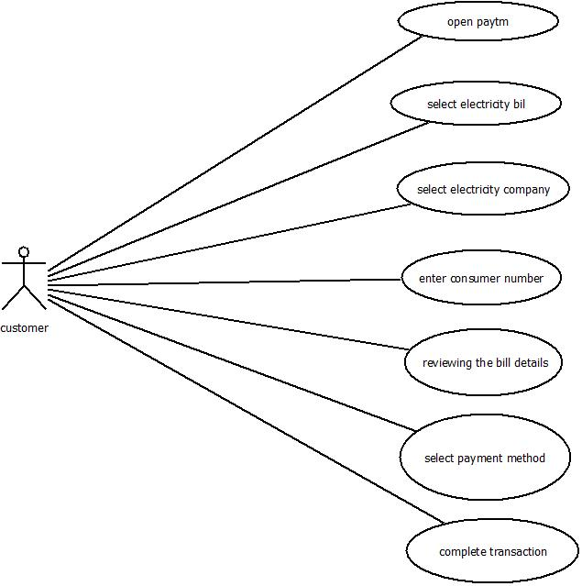

**18. Draw Usecase on banking system for customers.**

a.

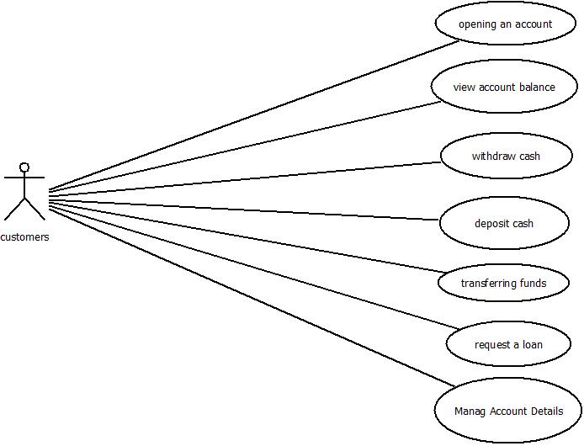

**19. Draw Usecase on Broadcasting System.**

a.

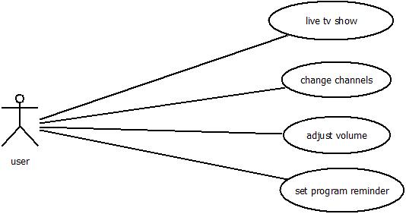

**20. Draw usecase on OTT Platform.**

a.

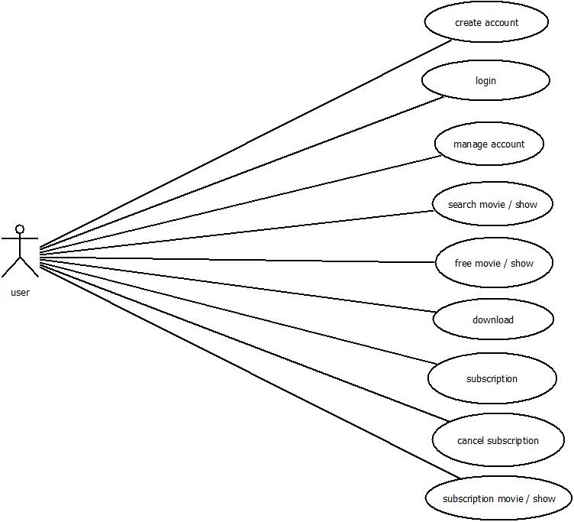

**21. Draw usecase on E-commerce application**

a.

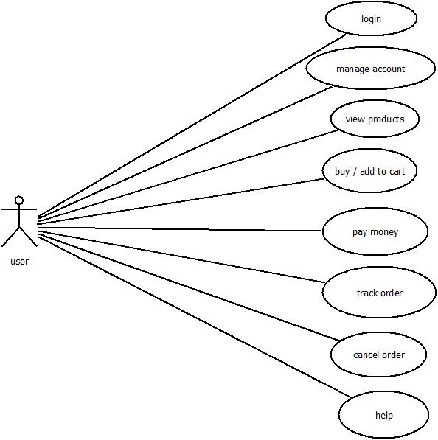

**22. Draw usecase on Online shopping product using payment gateway.**

a.

